Chapter 14
Financial Statement Analysis

- N
a. Inventory turnover ratio in 2009.
= 2850 / (490 + 480) x .5 = 1.47
b. Debt equity ratio in 2009.
= 3340 / 960 = 3.48
c. Cash flow from operating activities in 2009.
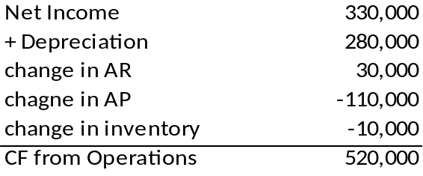

d. Average collection period.
= (660+690)x.5 / 5500 x 365 = 44.80
e. Asset turnover ratio.
= 5500 / (4300 + 4010) x .50 = 0.33
f. Interest coverage ratio.
= 870 / 130 = 6.69
g. Operating profit margin.
=870 / 5500 = 0.16
h. Return on equity.
= 410 / 960 = .43
i. P/E ratio.

j. Compound leverage ratio.
= (870 – 130) / 130 x 4300 / 960 = 3.81
k. Net cash provided by operating activities. See answer to part c.

- N
a.
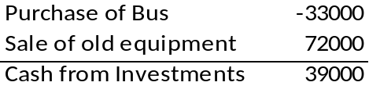
b.
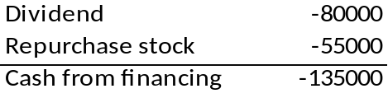
c.
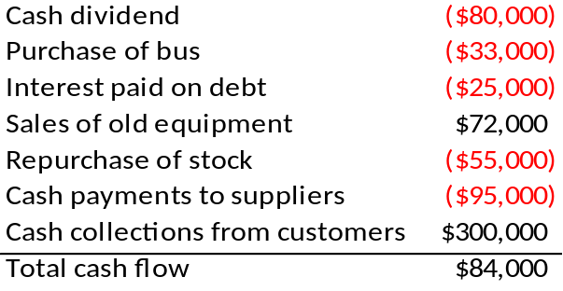

- ROA = (EBIT/Sales) × (Sales/Total Assets) = ROS × ATO
The only way that Crusty Pie can have an ROS higher than the industry average and an ROA equal to the industry average is for its ATO to be lower than the industry average.

- ABC’s asset turnover must be above the industry average.

- This transaction would increase the current ratio. The transaction reduces both current assets and current liabilities by the same amount, but the reduction has a larger proportionate impact on current liabilities than on current assets. Therefore, the current ratio would increase.
This transaction would increase the asset turnover ratio. Sales should remain unaffected, but assets are reduced.

- C

- C

- 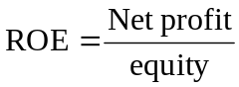 = 5.5% × 2.0 × 2.2 = 24.2%

- Using equation 14.1, solve for ROA
.03 = (1 - .35) x (ROA + (ROA - .06) x .5)
ROA = .05

- Using equation 14.3, solve for ROE
ROE = .75 x .6 x .10 x 2.4 x 1.25 = .135

Par value | 20,000 × $20 = | $ 400,000
Retained earnings |  | 5,000,000
Addition to Retained earnings |  | 70,000
Book value of equity |  | $5,470,000
Book value per share = $5,470,000/20,000 = $273.50

CFA 1

Since ROE is a function of net profit and equity, it is possible to maintain a stable ROE, while net profits decline so long as equity also declines proportionally.

CFA 2

(c) Old plant and equipment is likely to have a low net book value, making the ratio of “net sales to average net fixed assets” higher.

CFA 3

SmileWhite has the higher quality of earnings for several reasons:
• SmileWhite amortizes its goodwill over a shorter period than does QuickBrush. SmileWhite therefore presents more conservative earnings because it has greater goodwill amortization expense.
• SmileWhite depreciates its property, plant and equipment using an accelerated method. This results in earlier recognition of depreciation expense, so that income is more conservatively stated.
• SmileWhite’s bad debt allowance, as a percent of receivables, is greater. SmileWhite therefore recognizes higher bad-debt expense than does QuickBrush. If the actual collection experience for the two firms is comparable, then SmileWhite has the more conservative recognition policy.

CFA 4

Palomba Pizza Stores
Statement of Cash Flows
For Year Ended December 31, 2009
Cash flows from operating activities
Cash collections from customers | $250,000
Cash payments to suppliers | (85,000)
Cash payments for salaries | (45,000)
Cash payments for interest | (10,000)
Net cash provided by operating activities |  | $110,000
Cash flows from investing activities
Sale of equipment | 38,000
Purchase of equipment | (30,000)
Purchase of land | (14,000)
Net cash provided by (used in) investing activities |  | $ (6,000)
Cash flows from financing activities
Retirement of commons stock | (25,000)
Payment of dividends | (35,000)
Net cash provided by (used in) financing activities |  | $(60,000)
Net increase in cash |  | 44,000
Cash at beginning of year |  | 50,000
Cash at end of year |  | $ 94,000

  - Cash flow from operations (CFO) focuses on measuring the cash flow generated by operations, not on measuring profitability. If used as a measure of performance, CFO is less subject to distortion than the net income figure. Analysts use the CFO as a check on the quality of earnings. The CFO then becomes a check on the reported net earnings figure, although not as a substitute for net earnings. Companies with high net income but low CFO may be using income recognition techniques that are suspect. The ability of a firm to generate cash from operations on a consistent basis is one indication of the financial health of the firm. For most firms, CFO is the “life blood” of the firm. Analysts search for trends in CFO to indicate future cash conditions and the potential for cash flow problems.
Cash flow from investing activities (CFI) is an indication of how the firm is investing its excess cash. The analyst must consider the ability of the firm to continue to grow and expand activities; CFI is a good indication of the attitude of management in this area. Analysis of this component of total cash flow indicates the type of capital expenditures being made by management to either expand or maintain productive capability. CFI is also an indicator of the firm’s financial flexibility and its ability to generate sufficient cash to respond to unanticipated needs and opportunities. Decreasing CFI may be a sign of a slowdown in growth of the firm.
Cash flow from financing activities (CFF) presents the feasibility of financing, the sources of financing, and an indication of the types of sources management supports. Continued debt financing may signal a future cash flow problem. The dependency of a firm on external sources of financing (either debt or equity financing) may present troubles in the future with regard to debt servicing and maintaining dividend policy. Analysts also use CFF as an indication of the quality of earnings. It offers insights into the financial habits of management and potential future policies.

CFA 5

Chicago Refrigerator Co.
- Quick Ratio = =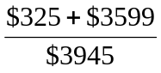= 0.99

- ROA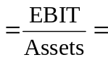
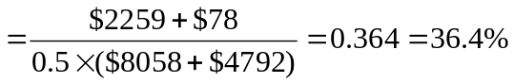

- ROE = 
Preferred dividends = 0.1 × $25 × 18,000 = $45,000
Common equity in 2009 = $829 + $575 + $1,949 = $3,353 million
Common equity in 2008 = $550 + $450 + $1,368 = $2,368 million
ROE = = 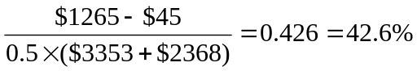

- Earnings per share 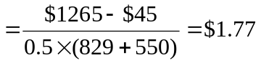

- Profit margin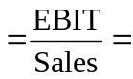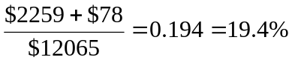
- Times interest earned = 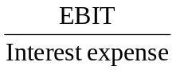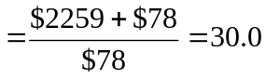

- Inventory turnover = 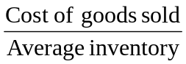=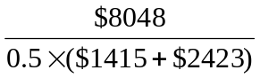= 4.19

- Leverage ratio = 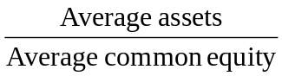= 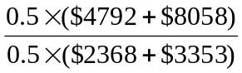= 2.25

CFA 6

  - QuickBrush has had higher sales and earnings growth (per share) than SmileWhite. Margins are also higher. But this does not necessarily mean that QuickBrush is a better investment. SmileWhite has a higher ROE, which has been stable, while QuickBrush’s ROE has been declining. We can use Du Pont analysis to identify the source of the difference in ROE:
Component | Definition | QuickBrush | SmileWhite
Tax burden (1 – t) | Net profit/Pretax profit | 67.4% | 66.0%
Interest burden | Pretax profit/EBIT | 1.00 | 0.955
Profit margin | EBIT/Sales | 8.5% | 6.5%
Asset turnover | Sales/Assets | 1.42 | 3.55
Leverage | Assets/Equity | 1.47 | 1.48
ROE | Net profit/Equity | 12.0% | 21.4%
While tax burden, interest burden, and leverage are similar, profit margin and asset turnover differ. Although SmileWhite has a lower profit margin, it has far higher asset turnover.
Sustainable growth = ROE × plowback ratio
 | ROE | Plowback ratio | Sustainable growth rate | Ludlow’s estimate
QuickBrush | 12.0% | 1.00 | 12.0% | 30.0%
SmileWhite | 21.4% | 0.34 | 7.3% | 10.0%
Ludlow has overestimated the sustainable growth rate for each company. QuickBrush has little ability to increase its sustainable growth because plowback already equals 100%. SmileWhite could increase its sustainable growth by increasing its plowback ratio.

  - QuickBrush’s recent EPS growth has been achieved by increasing book value per share, not by achieving greater profits per dollar of equity. Since EPS is equal to (Book value per share × ROE), a firm can increase EPS even if ROE is declining; this is the case for QuickBrush. QuickBrush’s book value per share has more than doubled in the last two years.
Book value per share can increase either by retaining earnings or by issuing new stock at a market price greater than book value. QuickBrush has been retaining all earnings, but the increase in the number of outstanding shares indicates that it has also issued a substantial amount of stock.

CFA 7
  - ROE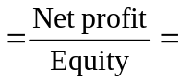
= Tax-burden × Interest burden × Profit margin × Asset turnover × Leverage
Tax burden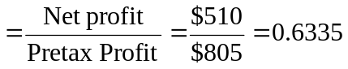
Interest burden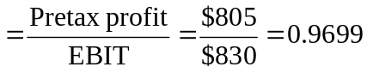
Profit margin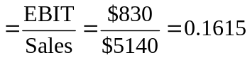
Asset turnover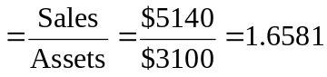
Leverage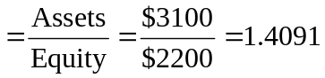

  - ROE = 0.6335 × 0.9699 × 0.1615 × 1.6581 × 1.4091 = 0.2318 = 23.18%

  - g = ROE × plowback = 0.2318 × 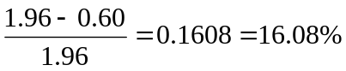

CFA 8

 | 2006 | 2009

Operating margin = 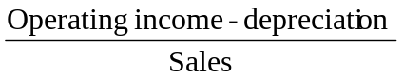 | 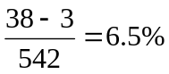 | 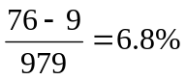
Asset turnover = 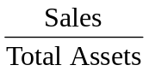 | 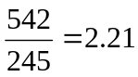 | 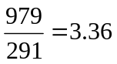
Interest Burden = 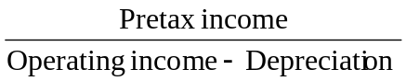 | 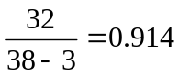 | 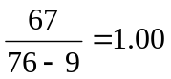
Financial Leverage =  | 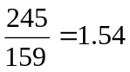 | 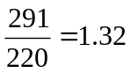
Income tax rate =  | 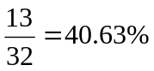 | 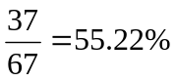
Using the Du Pont formula:
ROE(2001) = (1 – 0.4063) × 0.914 × 0.065 × 2.21 × 1.54 = 0.120 = 12.0%
ROE(2005) = (1 - 0.5522) × 1.0 × 0.068 × 3.36 × 1.32 = 0.135 = 13.5%

- Asset turnover measures the ability of a company to minimize the level of assets (current or fixed) to support its level of sales. The asset turnover increased substantially over the period, thus contributing to an increase in the ROE.
- Financial leverage measures the amount of financing, not including equity, but including short and long-term debt, that the firm uses. Financial leverage declined over the period, thus adversely affecting the ROE. Since asset turnover increased substantially more than financial leverage declined, the net effect was an increase in ROE.

